COSC 363 Assignment 1
Harrison Cook – 52210542

Scene Description:
The scene consists of a crenelated stone castle containing a spaceship and two floating robots patrolling its walls. There are two quadruped robots patrolling around the outside of the castle in a circle and there are two cannons at the entrance to the castle ready to fire. The castle is surrounded by sandy ground on a sunny desert day.
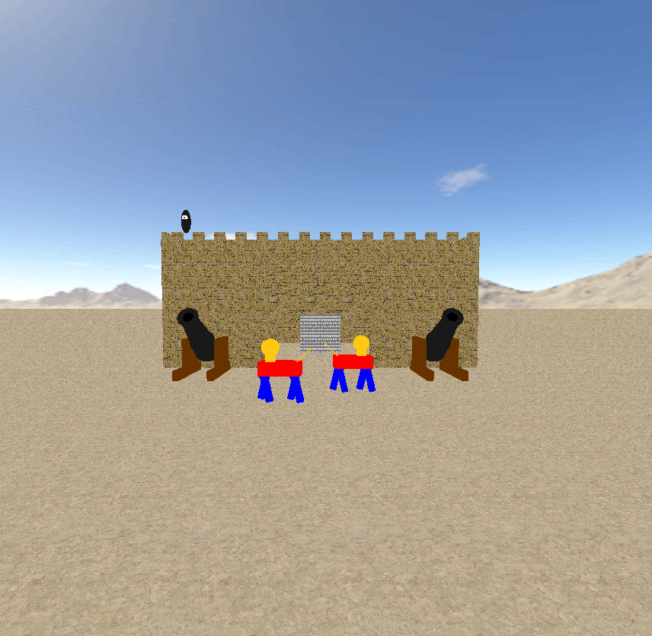
Screenshot 1: The position the user begins at, with patrolling robots, cannons and the spaceship
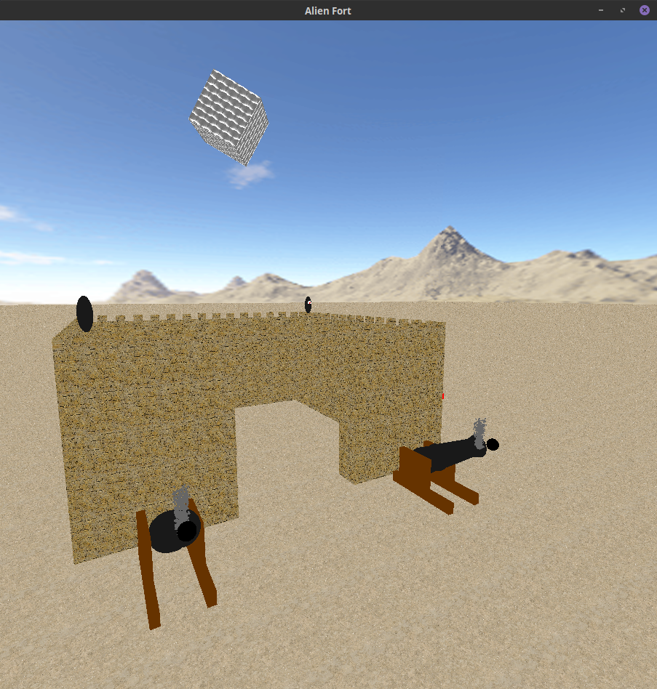
Screenshot 2: Spaceship mid lift-off, with rotation enabled. Cannons firing with smoke particles.

Extra Features:
Additional animated system:
Two custom-made floating robots are also deployed atop the castle walls. These robots move backwards and forwards along the two walls parallel with the z-axis. The two floating robots float upwards and downwards to seem more realistic. The two robots also stop and slowly rotate to face the opposite direction when switching from moving forwards to moving backwards.

Two camera modes:
A second camera mode was added giving the view from the spaceship. This camera mode can be toggled by pressing the HOME key. When the spaceship is on the ground, the view is looking forward from the spaceship towards the castle entrance. As the spaceship lifts off the view rotates to look down towards the castle, a small part of the spaceship is also visible to help the user understand their position.

The second view does not interfere with the first, and the first view’s position is maintained and will appear unchanged when toggled back to. Any use of the movement keys (other than the HOME key) has no effect on the second view, and has no effect on the first view when the second view is being used.

Collision detection:
There is collision detection enabled for the floor plane, the skybox, the castle itself, the cannons and the landed spaceship. Since I added the functionality for the user to move the camera up or down, the collision detection includes stopping the user from moving up or down into objects. The castle collision detection includes the crenelation height when checking if there is a collision. The cannon collision detection treats the cannon as if it is a cube, with the bounds of the cube being the outermost parts of the cannon. In addition, the user cannot move the camera much higher than the castle (20 units).

Skybox:
A skybox is included using the desert texture provided (skybox2), the skybox is a 1000x1000x1000 unit cube and has no visible corners.

Particle System:
A particle system is present, when the cannons fire, smoke particles are generated and slowly dissipate as they get higher. New smoke particles are generated for a time then generation is halted. The particles themselves are glut solid spheres, I chose these over using vertices as it give the smoke a thicker, more realistic look. The generation of smoke can be turned back on after turning off by pressing ‘p’.

Challenges Faced:
Spaceship texture:
When creating the spaceship initially, I wanted to create a Borg Cube from Star Trek. However, due to copyright concerns I couldn’t use the Borg Cube textures. So I textured the cube with a copyright free texture, and then I animated the texture. I spent a long time trying to get the animation right, in the end I am happy with the result. The texture ‘zooms out’ and ‘zooms in’, and the ‘zooming’ gets slower as the texture comes closer to switching from ‘zooming out’ to ‘zooming in’ or vice-versa.

Control keys:
Prescribed keys:
- Up arrow – Moves camera forward in current direction.
- Down Arrow – Moves camera backwards in current direction.
- Left Arrow – Rotates camera left by 5 degrees.
- Right Arrow – Rotates camera right by 5 degrees.
- ‘S’ Key – Initiates spaceship lift-off
- ‘C’ Key – Fires the cannonball from the cannon
- Home Key – Switches the camera to the spaceship view
Custom keys:
- Page Up – Increases the height of the camera
- Page Down – Decreases the height of the camera
- ‘P’ Key – Toggles generation of new smoke particles
- ‘R’ Key – Toggles random rotation of the spaceship
- ‘E’ Key – Resets spaceship rotation to 0 on all axises
  - These last two are present as I had the spaceship rotate randomly during lift-off. After adding the second camera mode (spaceship view), the rotation did not look right from the spaceship view, hence I removed the rotation as default and allowed the user to toggle it themselves. The camera does not rotate with the spaceship.
References & Resources:
- Skybox Texture: Skybox2 provided by Mukundan
- Floor Texture: Taken free from textures.com - https://www.textures.com/download/soilsand0231/110850
- Castle Texture & Crenelation Texture: Taken free from opengameart.org, provided by p0ss - https://opengameart.org/content/117-stone-wall-tilable-textures-in-8-themes
- Spaceship Texture: Taken free from textures.com - https://www.textures.com/download/metalbare0144/30950

